Inter-VLAN Routing Lab Rebuild Guide
Cisco Packet Tracer • Router-on-a-Stick • VLAN Communication
1. What This Lab Is Teaching You
This lab introduces Inter-VLAN Routing, which allows communication between segmented networks.
- VLANs isolate traffic at Layer 2
- Devices in different VLANs cannot communicate by default
- A router enables communication between VLANs
- Router-on-a-Stick uses subinterfaces to route VLAN traffic
2. Real-World Context
Organizations use VLANs to separate departments, devices, and security zones. Inter-VLAN routing allows controlled communication between these groups.
3. Topology Overview
- 1 Router
- 1 Switch
- 4 PCs
- VLAN 20 and VLAN 30
All devices connect to the switch, which connects to the router via a trunk link.
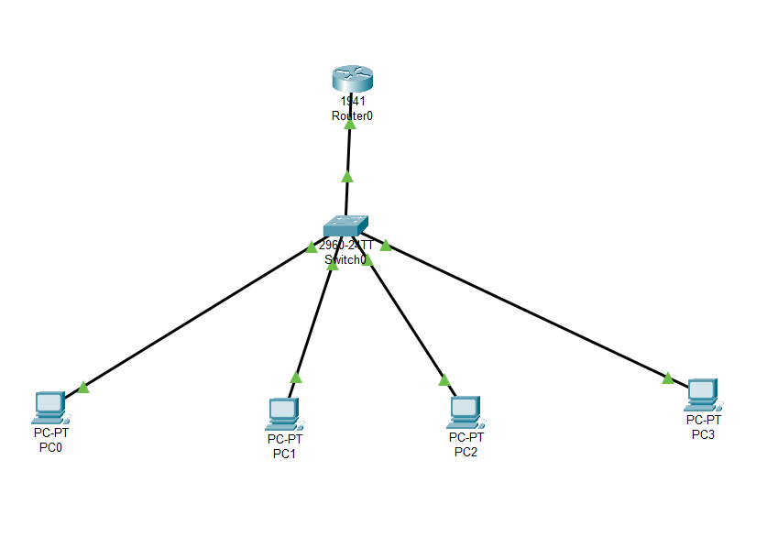
4. IP Addressing Scheme (Corrected)
VLAN 20:
- PC0: 172.16.1.2
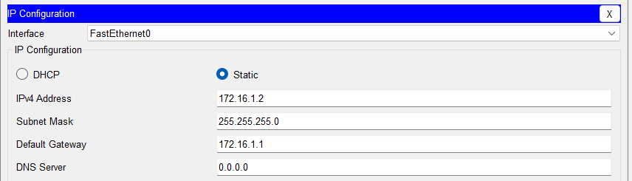

- PC1: 172.16.1.3
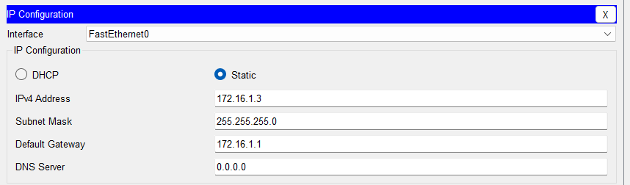
- Gateway: 172.16.1.1
VLAN 30:
- PC2: 172.16.2.4
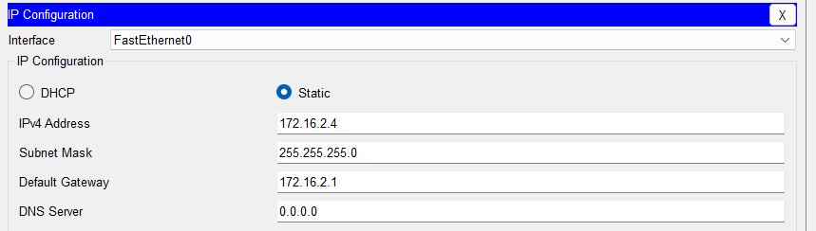
- PC3: 172.16.2.5
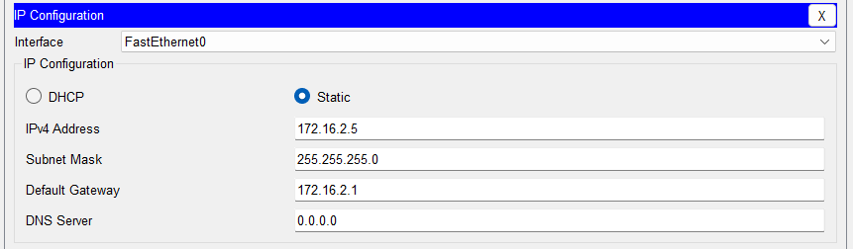
- Gateway: 172.16.2.1
5. Build the Topology
1. Open Packet Tracer
2. Add 1 Router, 1 Switch, 4 PCs
3. Connect all PCs to switch
4. Connect switch to router (G0/0)
6. Configure VLANs on the Switch
enable
configure terminal
vlan 20
vlan 30
interface f0/1
switchport mode access
switchport access vlan 20
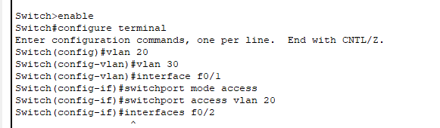
interface f0/2
switchport mode access
switchport access vlan 20
interface f0/3
switchport mode access
switchport access vlan 30
interface f0/4
switchport mode access
switchport access vlan 30
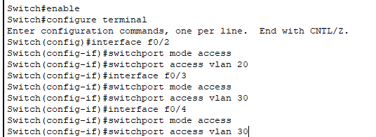
7. Configure Trunk Port
interface g0/1
switchport mode trunk
8. Configure Router (Router-on-a-Stick)
enable
configure terminal
interface g0/0.20
encapsulation dot1Q 20
ip address 172.16.1.1 255.255.255.0
interface g0/0.30
encapsulation dot1Q 30
ip address 172.16.2.1 255.255.255.0
no shutdown
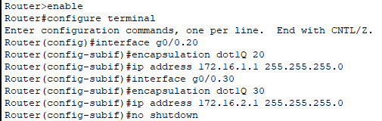

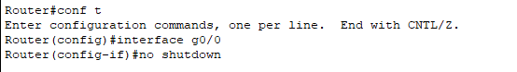
9. Configure PCs
Assign correct IP addresses and default gateways for each VLAN.
10. Test Connectivity
Before routing: VLAN communication should fail.
After routing: VLAN communication should succeed.

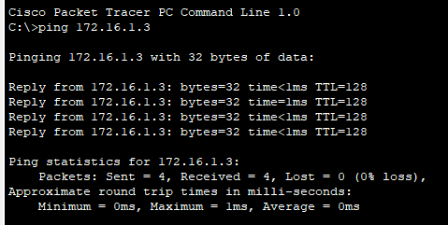
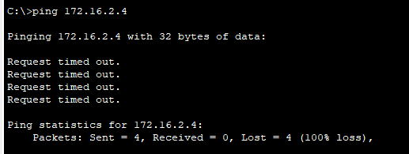
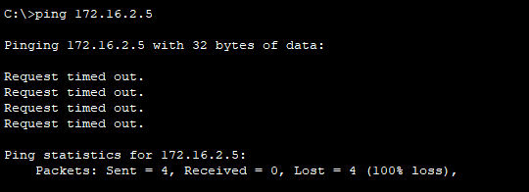

PC1
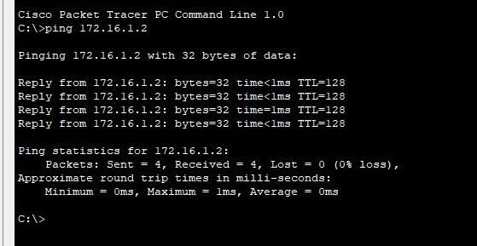
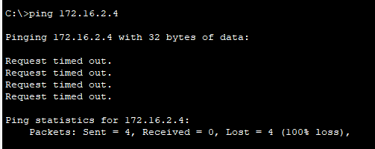
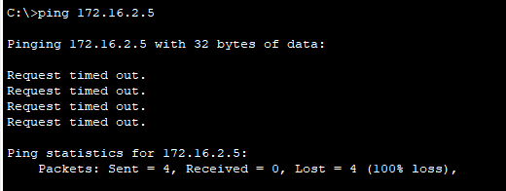

PC2
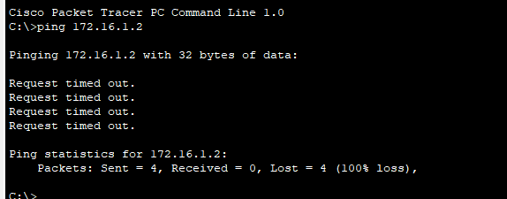
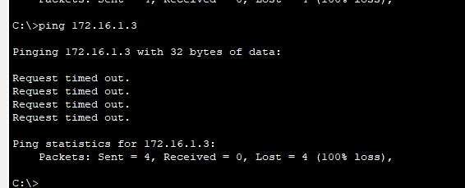
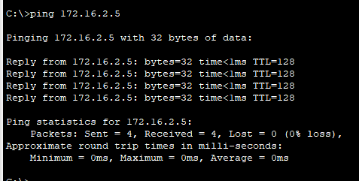

PC3
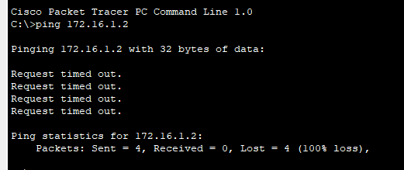
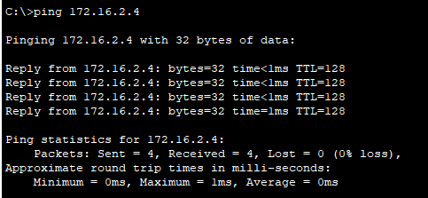

After Routing
PC0-PC2
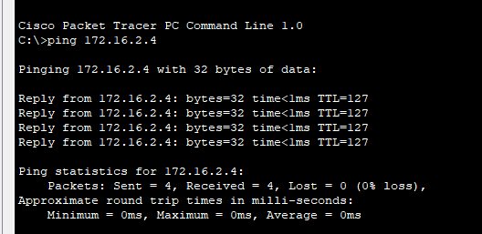
PC0-PC3
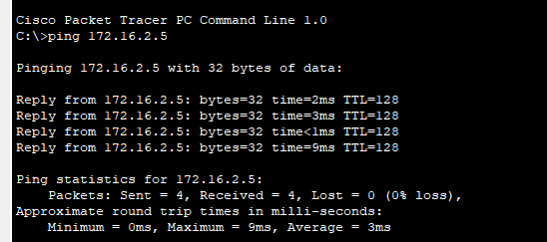

PC1-PC2
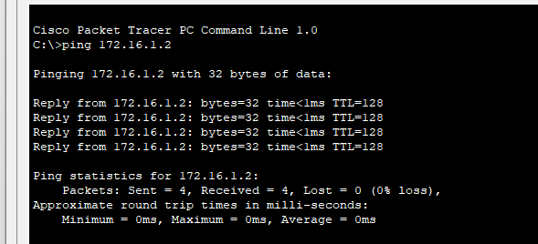

PC1-PC3
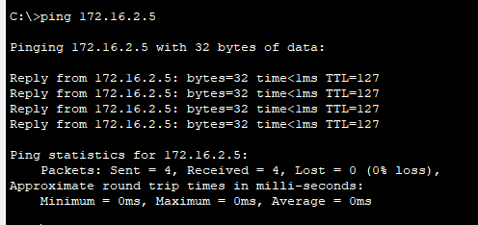

PC2-PC0
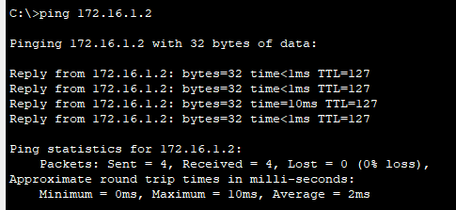
PC2-PC1
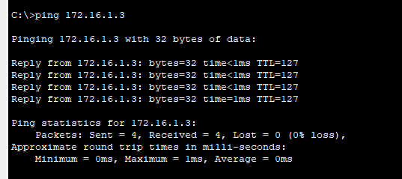

PC3-PC0
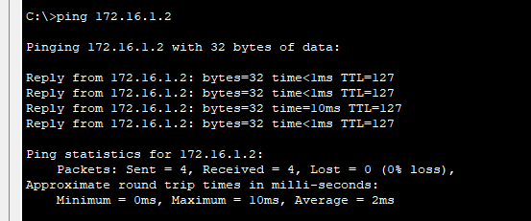

PC3-PC1
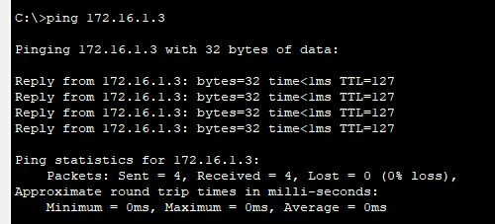
The pings above are the ones that are done before the trunking. Meaning that the router has not been configured yet to enable the vlans to communicate outside the network yet.
Final topology with everything connected
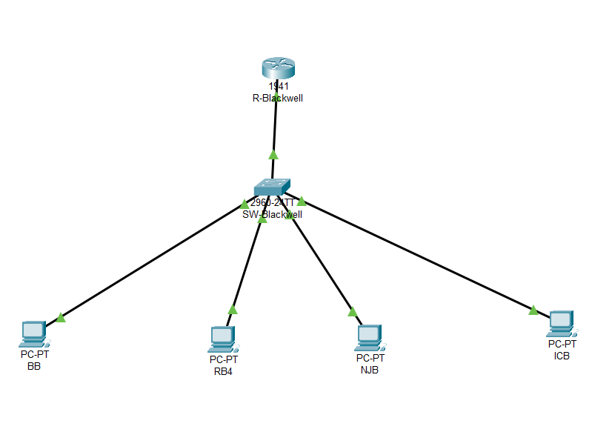
11. Screenshot Checklist
- VLAN configuration
- Trunk configuration
- Router subinterfaces
- Failed ping
- Successful ping
- Topology
12. Professional Interpretation
Routers enable controlled communication between VLANs. Subinterfaces map VLAN IDs and encapsulation enables tagging.
13. Common Mistakes
- Same subnet used across VLANs
- Missing trunk configuration
- Wrong gateway
- Missing encapsulation
- Interfaces shut down
14. Real-World Reflection
This lab reflects how organizations use segmentation and routing to control communication and reduce risk.

15. Research Prompts for Understanding
These questions are designed to reinforce understanding beyond configuration by requiring analysis of how traffic flows, how routing decisions are made, and how segmentation impacts network behavior and security.

Core Concept Questions (Foundation)
- What problem do VLANs solve in a network? Through logical partitioning of a single network, they are used to deal with issues such as congestion caused by excessive broadcast traffic, security risk, and the lack of a physical network to scale.
- Why can devices in different VLANs not communicate by default? Mainly because they are treated as separate logical networks. Essentially through vlans one creates different silos of the network for a given department of sector within the organization.
- What role does a router play in inter-VLAN communication? The router acts as the default gateway (allows external communication) so that the siloed vlans can communicate with other subnets. This is defined as layer 3 routing.
- What is the difference between Layer 2 and Layer 3 communication? Layer 2 is the data link layer, and it is where MAC addresses and switches reside. For the sake of review remember that switches utilize mac addresses to communication throughout the network. Layer 3 is defined as the network layer, and this is where the router resides. Routers utilizes IP addresses to communicate through the network.

Router-on-a-Stick (Critical)
- What is router-on-a-stick and when is it used? Also known as ROAS, it Is when a router connects to a switch to route traffic between multiple VLAN. It achieves this through the use of 802.1Q tagging.
- Why are subinterfaces required instead of using physical interfaces? So that we can divide a physical port into multiple logical interfaces. This will allow on router or firewall port to handle multiple VLANs (This defines the trunking)
- What does encapsulation dot1Q do? Enable tagging on network interfaces. It also allow a physical link to carry traffic for multiple VLANs. A 4-byte tag is added to an ethernet frame to identify it as the VLAN.
- How does the router distinguish traffic from different VLANs? Through the use of the tagging protocol mentioned above. The sub interfaces are mapped to a specific VLAN ID.

VLAN Tagging & Trunking
- What is VLAN tagging? Describe the process of adding a VLAN ID to a network packet(s) to identify which virtual network they belong to. It allow the switches to separate traffic from different VLANs.
- How does a trunk port carry multiple VLANs? Through the use of tagging adding that 4-byte header to the ethernet frame.
- What happens to VLAN tags when traffic leaves the switch? The VLAN tags are removed or left on dependent on the port configuration.
- Why must the switch port connected to the router be a trunk? Its only necessary when traffic needs to be routed for multiple VLANs over a single physical cable (ROAS). If it is only one VLAN it is not necessary or a dedicated physical interface.

IP Addressing & Gateways
- Why does each VLAN require a different subnet? VLANs divide broadcast domains. Subnets will provide the logical address needed to route traffic between the isolated segments. Separation is good for security, minimize traffic, and also help to define distinct logical networks.
- What happens if both VLANs use the same subnet? Breaks network segmentation and the respective devices would not be able to communicate directly with each other.
- Why does each VLAN have a different default gateway? Because each VLAN is considered to be its on entity meaning it will contain it’s on subnet or broadcast domain.
- How does a device know to send traffic to its gateway? By comparing its IP address to the where it’s going (Destination IP address)

Traffic Flow
- How does a packet travel from VLAN 20 to VLAN 30? Moving from layer 2 to layer 3.
- What happens at the switch, trunk port, and router?
- Switch: Acts as a traffic directory within the LAN
- The trunk port will operate as the multi-VLAN gateway through the use of tagging.
- The router will e the layer 3 gateway..
- When is the VLAN tag added and removed? When the untagged traffic enters a switch or when leaving a switch on a tagged trunk port. The tag is removed when the traffic leaves the switch or the native VLAN on a trunk link.

Troubleshooting Thinking
- Why would inter-VLAN communication fail even if VLANs are configured? Could be missing layer 3 routing, the trunk ports could be misconfigured or there is no layer 3 device such as a switch.
- What happens if trunking is not configured? The VLANs will not pass over a single link. Only the devices that exist on the same VLAN would be able to communicate.
- What happens if encapsulation is missing? The traffic will fail to cross the switch. Or the traffic maybe dropped all together. And that drop would lead to the untagged VLANs dropping into the native VLAN or cause a connectivity failure.
- What happens if the gateway is incorrect? Devices would only be able to communicate with those computers that is on the same local network. They will not be able to access remote networks.
- What happens if the router interface is down? Physical link is broken, or disabled and traffic is halted, as well as routing updates and connection through the respective port.

Security & Real-World Thinking
- How does inter-VLAN routing impact security? Enable communication between isolated network segments. This provides that balance between network segmentation and resources balancing. Routing between the VLANs, conversely, breaks up the isolation that is used to protect against attacks, thus through the use of Access Control list or firewalls communication can be monitored accordingly.
- Why might organizations restrict VLAN communication? To enhance security by preventing lateral movement of threats. They also do it to limit broadcast traffic to boost network performance (decreasing congestion); Also, it is done to segment sensitive data from general user traffic.
- How can improper routing increase attack surface? It creates unintended, unprotected or misdirected network paths exposing internal stuff to external threats. This is where MitM attacks are so effective if such a thing exist. Reconnaissance can be performed and unauthorized access can be gained.
- How does this relate to lateral movement? Because f a threat is able to maneuver each segment then that just increases the potential damage at which they can cause through the expansion of their control

